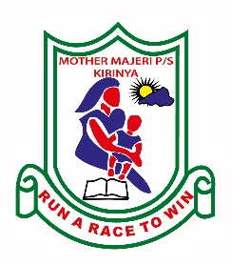**MOTHER MAJERI NURSERY SCHOOL**

**END OF TERM II EXAMINATION, 2024**

**CLASS : TOP**

**SUBJECT: DRAWING & SHADING**

**Name __________________________________________________________**

**Stream _____________________**

**1. Draw these foods.**

|  |  |  |  |  |
| --- | --- | --- | --- | --- |
|  |  |  |  |  |
| eggs | Irish potato | yam | rice | banana |

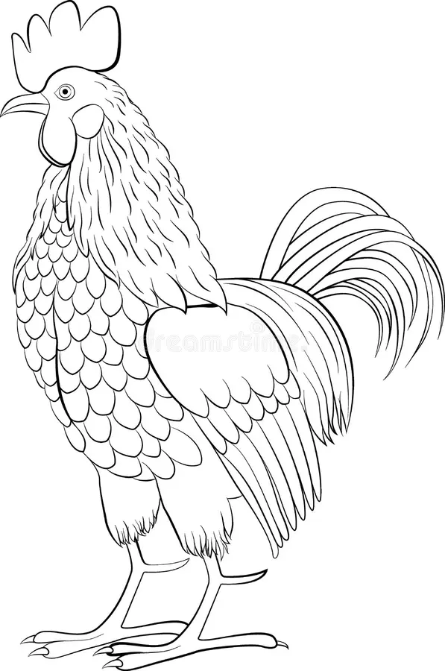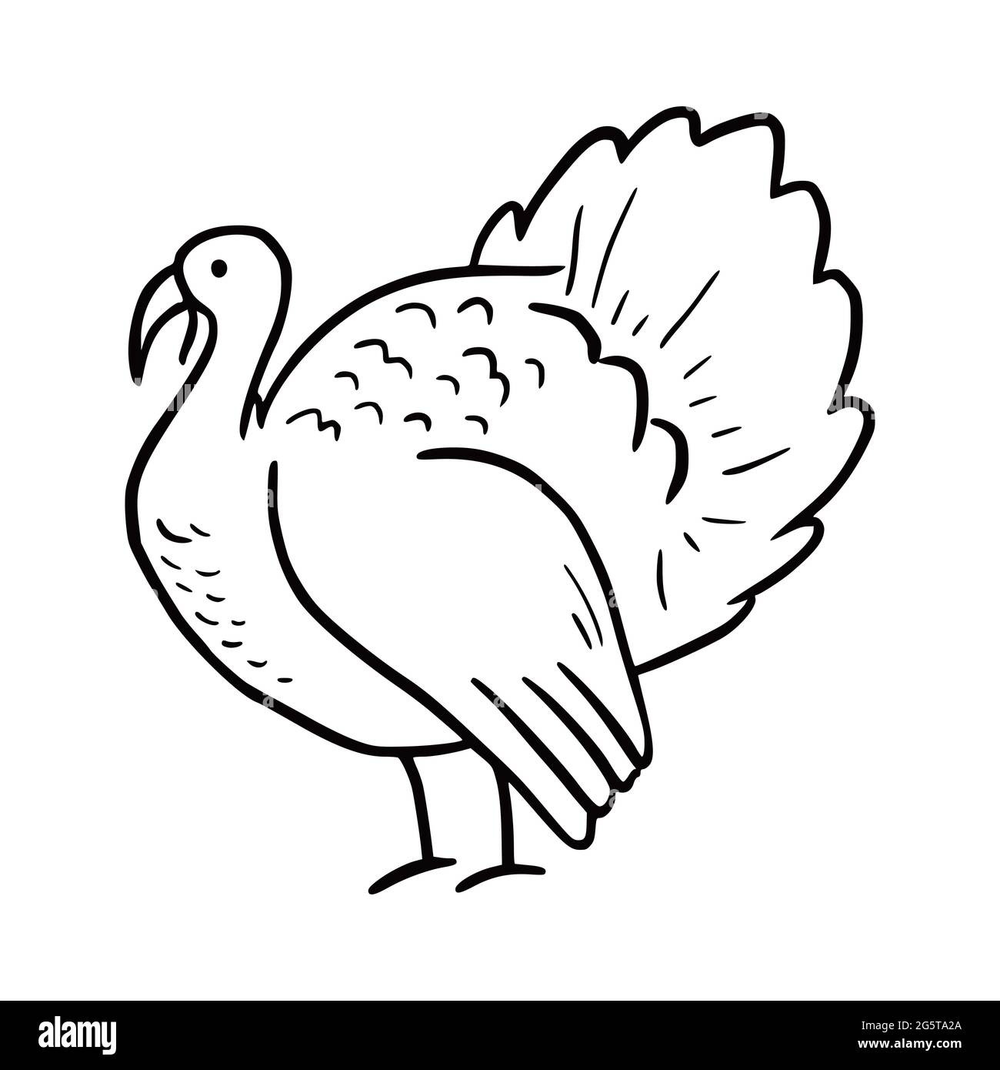**2. Shade these domestic birds.**

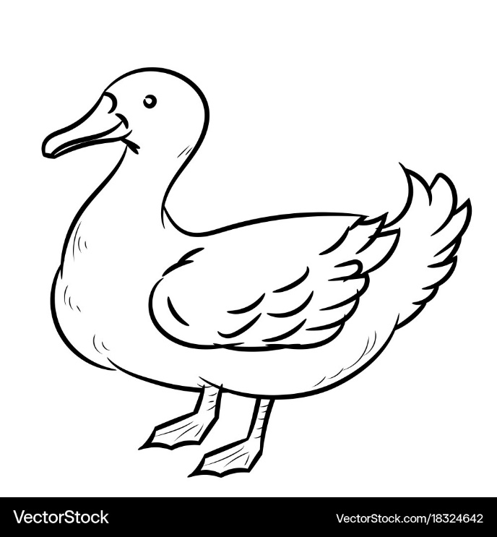

**3. Read and draw.**

|  |  |  |  |  |
| --- | --- | --- | --- | --- |
|  |  |  |  |  |
| well | borehole | rain | lake | tap |

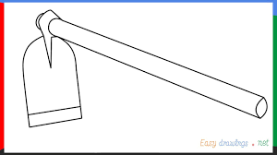**4. Shade me well.**

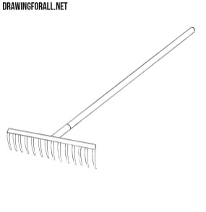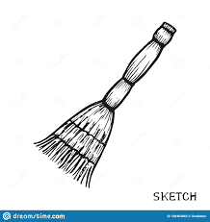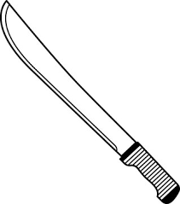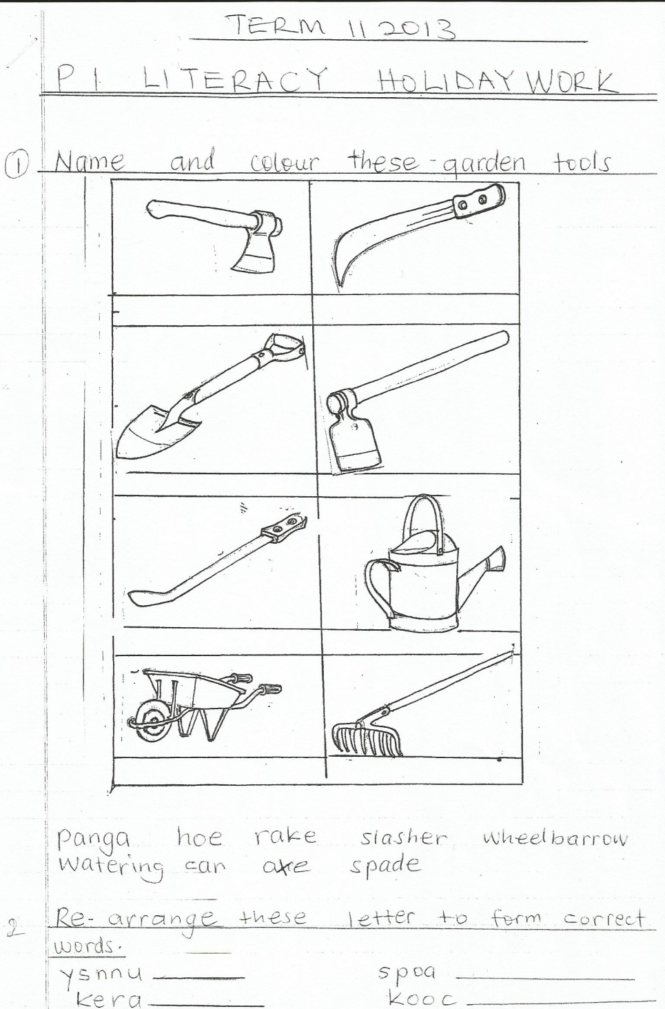 hoe

broom

panga

rake

slasher

**5. Read and draw.**

|  |  |  |  |  |
| --- | --- | --- | --- | --- |
|  |  |  |  |  |
| dress | shirt | trousers | vest | sweater |

**END**